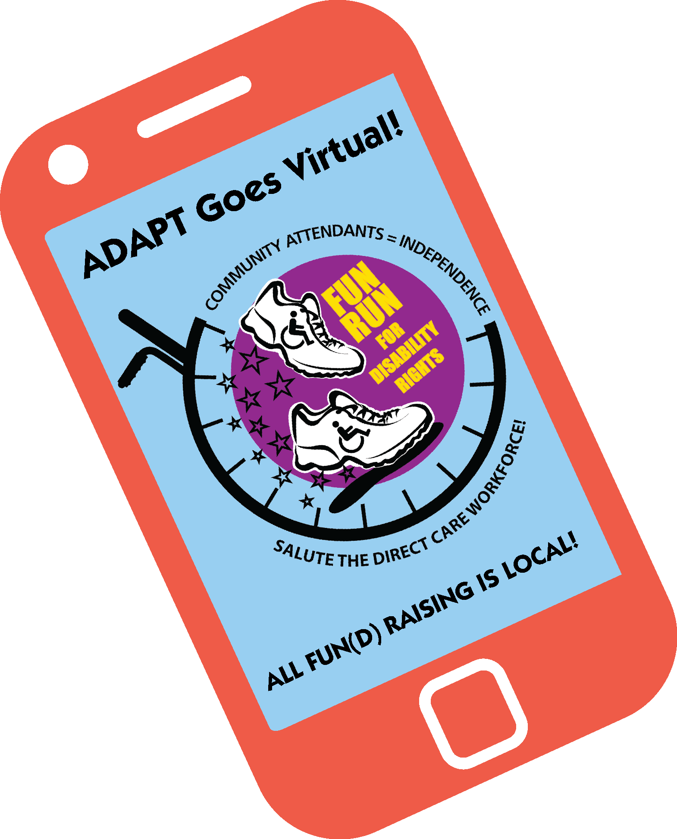

February 2022
Dear Advocates / Community Partners:
We would like you to join us in a virtual grassroots fundraising event, the Virtual FUN RUN for Disability Rights. www.adaptfunrun.net
The Virtual FUN RUN for Disability Rights is a cooperative fundraiser hosted by National ADAPT which will be held on Saturday, April 30th.
All funds raised are tax deductible and will be split 90% to your organization and 10% to National ADAPT.
- To begin, your Organization has to be listed as a Virtual FUN RUN participating organization on the FUN RUN website www.adaptfunrun.net
- To do this just e-mail or call Bob Kafka at bob.adapt@sbcglobal.net 512 431 4085 with your Organization’s name and contact information.
- Your organization will then be listed on the website. Once your Organization is listed, people who want to support your organization have to register for the Virtual FUN RUN by going to the Fun Run website www.adaptfunrun.net
- When they register they will be asked which organization they want to support. Instruct them to select your Organization.
- After they finish registering they will receive their own Dashboard and a Personal Sponsor Link by email.
- To get back to your Dashboard log in to the FUN RUN website using your email and password you created when registering.
- This Personal Link is the key to recruiting pledges. To Recruit Pledges the person can send a note with this link to their e-mail address book and/or paste the link into their Facebook or other Social Media platforms.
- This link will be found on the registered runner’s Dashboard at the “Recruiting Sponsors” tab.
- Attached is Bob Kafka’s personal link as an example of what a link looks like. http://adaptfunrun.net/runner/message/1999
- Each time a pledge is made for the registered FUN RUNNER, the individual can choose to receive an e-mail informing them about the pledge.
- For accountability, when a FUN RUNNER logs into the website and goes to their Dashboard, there will be a “Reports” tab that will have their “Individual” information on all the people that have made pledges to them and if the person has paid.
- In addition there is an “Organization” report that lists all the other people that have registered supporting your Organization and how much they have raised (totals but not their individual sponsors).
- All the individual/organization pledged information is private. National ADAPT does not use this information for any future fundraising or any other purpose.
- This information is solely for your Organization’s use. We delete the information after the FUN RUN is over.
- Approximately a week after the FUN RUN is over, National ADAPT will send out an e-mail bill for those who have not previously paid. Two weeks later we will do a second billing.
- You can expect your 90% split amount and a final report one month after the FUN RUN.
I want to encourage your organization to participate. If you have any questions please contact Bob at bob.adapt@sbcglobal.net 512 431 4085

Thanks for the support,

Bob Kafka FUN RUN Coordinator
Nancy Salandra, Fundraising Group
Josue Rodriguez, Fundraising Group

