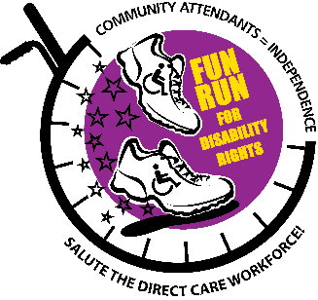
COMMUNITY ATTENDANT = INDEPENDENCE
ARTWORK AND POETRY CONTEST
SUBMITTAL FORM
The theme for the 2022 FUN RUN for Disability Rights being held Saturday, April 30th is COMMUNITY ATTENDANTS = INDEPENDENCE.
To highlight the voices and stories of COMMUNITY ATTENDANTS we will be asking COMMUNITY ATTENDANTS to submit an original piece of artwork or an original poem. The submitted artwork/poem can embrace any subject or theme. Criteria is that it is done by a COMMUNITY ATTENDANT.
Community Attendant – an individual who provides physical, cognitive, emotional and/or sensory assistance to a person with a disability of any age.
Art – the expression or application of human creative skill and imagination…to be appreciated primarily for its beauty or emotional power.
Poetry – work in which feelings/emotions and ideas are expressed with a distinctive style and rhythm.
We will recognize the top 3 submittals by awarding 3 cash prizes of $250, $150 and $100.
All submittals must be electronic. DEADLINE: April 15th 6pm eastern
Send your submittal to: Josue josue.adapt@yahoo.com or to DropBox here.
Name of Community Attendant___________________________
How long have you been an COMMUNITY ATTENDANT____________
Address _____________________________State________Zip___________
Email ___________________________ Phone________________
Submitting ____________Artwork ____________Poetry

